What is done for training:

* load and validate text data from CSV files, ensuring required columns are present.
* Preprocess the data by tokenizing text and splitting it into training and validation sets.
* Models ‘*deberta-large’*,*’xlm-r-100langs-bert-base-nli-stsb-mean-tokens*’,’*roberta-base-openai-detector’*,*’roberta-large’* are used for training on train dataset.
* The model is trained using the Hugging Face Trainer API, with evaluation and checkpointing at each epoch.
* Post-training, predictions are generated, converted to probabilities, and saved as a CSV file.

(Final predictions are obtained by taking the probabilities of each class and feeding them into VotingClassifier with model RandomForestClassifier, Support Vector Machine(SVC), LogisticRegression, Gaussian Naive Bayes(GB).

Training Configuration:

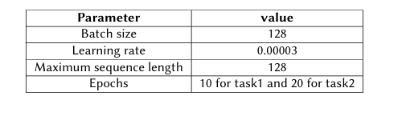

Evaluation of each model:

|  |  |  |  |  |
| --- | --- | --- | --- | --- |
| Model | Accuracy | Fmacro | Precision | Recall |
| deberta-large | 0.989996 | 0.990005 | 0.990213 | 0.989996 |
| xlm-r-100langs-bert-base-nli-stsb-mean-tokens | 0.983193 | 0.983210 | 03983512 | 0.983193 |
| roberta-base-openai-detector | 0.973990 | 0.974037 | 0.975404 | 0.973990 |
| roberta-large | 0.989596 | 0.989603 | 0.989713 | 0.989596 |
| Ensemble with Votingclassifier (PC as input feature) | **0.9988** | **0.9988** | **0.9988** | **0.9988** |

Confusion Matrix from Voting Classifier:  
  
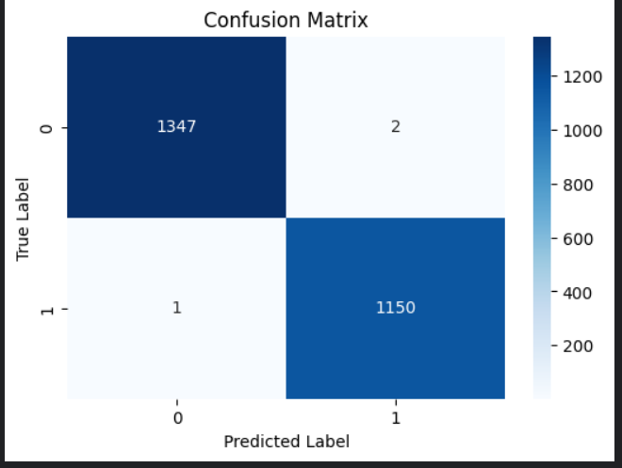

Training on ‘Jinyan1/COLING_2025_MGT_en’

* Training procedure same as above.
* The batch size for ‘deberta-v3-large’ is taken 16 as taking 128 gave Out-of-Memory Error.
* The other configuration is not changed.

Evaluation of each model:

|  |  |  |  |  |
| --- | --- | --- | --- | --- |
| Model | Accuracy | Fmacro | Precision | Recall |
| deberta-large | 0.80800 | 0.794713 | 0.824036 | 0.80800 |
| xlm-r-100langs-bert-base-nli-stsb-mean-tokens | 0.782667 | 0.756587 | 0.804238 | 0.782667 |
| roberta-base-openai-detector | 0.79600 | 0.779799 | 0.802808 | 0.79600 |
| roberta-large | 0.729333 | 0.0.701592 | 0.738536 | 0.729333 |
| Ensemble with Votingclassifier (PC as input feature) | **0.8540** | **0.8548** | **0.8540** | **0.8539** |

